NANOMXCN Extended Abstract Template
(Title Should Be Centred 14 pt Time (Bold) font, with Title Case Formatting – Elements and Acronyms Should Be Capitalized)

Aaaa Bbbb-Cccc¹, Ddddd Eeee ^{2,a)}, Fffff Ggggg ^{1,2, b)}
1. First full affiliation including Department/Centre/Group, Institution, City, Region/State, Country
2. Second full affiliation including Department/Centre/Group, Institution, City, Region/State, Country

Please follow this template for the one page abstract for submissions to WNN-2018. This template is provided in Microsoft Word and PDF formats, however the submitted document must be in PDF format. Paper size should be A4 format (210 mm x 297 mm). Margins should be set for a 2.5 cm top, bottom, left, and right. For text fonts: use only 10pt Times (roman, bold or italic), and Symbol. Sans Serif Fonts such as Arial can be used in Figures. Include all equations, drawings, figures and references within the one page limit. Do not add page numbers.
Note that the Author name(s) should use 10-point type, [centered, bolded], the presenting author’s name should be underlined. The author’s affiliation should include full address and should use 8-point type [centered, italicized). Please include the corresponding Email addresses of both the presenting and corresponding authors as indicated below.
Please be concise in your presentation and highlight novelty and originality. Simple equations should be included in-line wherever possible, whereas more complex expressions should be centered and numbered if there are several. Figures, if any, must be grey scale, should be relevant to the submission. Figures should be placed close to the text where they are mentioned and should appear centered. Figure captions should be centered beneath figures, please use 8-point font. Figure captions should be indented 1 cm on both sides and justified on both right and left sides.
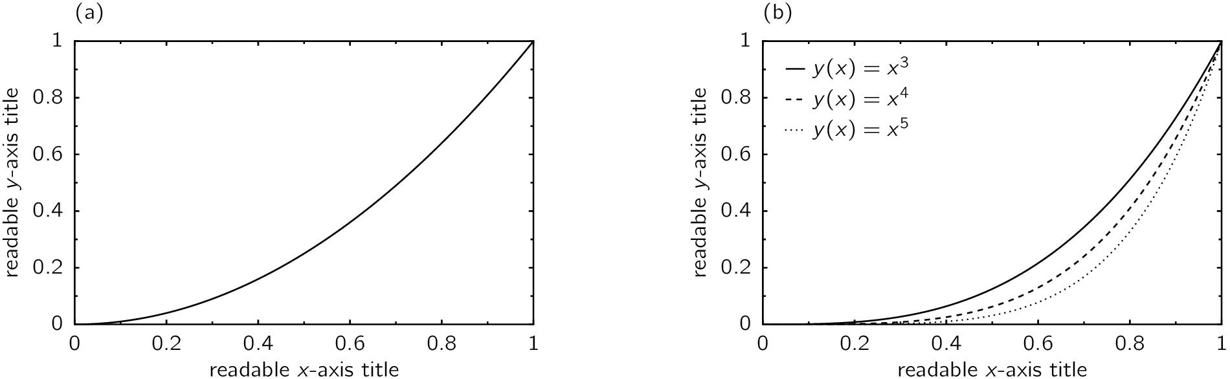

Fig. 1 The abbreviation “Fig.” with number should appear first (in bold) followed by the figure caption.

References should appear at the end of the abstract in the order in which they are referenced. For references please use 8 point font and left alignment. Authors are listed first, followed by the title in italic, the journal’s title abbreviation, the volume number in bold, page number, the year in parentheses, and a period at the end Within the main text, references should be designated by a number in brackets [1], and they should precede a comma or period [2]. Two references cited at once should be included together [2,3], separated by a comma, while three or more consecutive references should be indicated by the bounding numbers and a dash [1–3].

Acknowledgements. If any, acknowledgements should be placed before the References. Use font 10pt Times, justified.

Correspondance. a) Presenting author’s Email, b) Corresponding author’s Email (if different from presenting author)
References
[1] Aaaa Bbbb Cccc, Ddddd Eeee Fffff, Reference Example, J. Name. 123, 123456 (2000).
[2] Gggg Hhhh, Another Example, Science 123, 1234 (2000).
[3] John Doe, Yet Another Example, J. Phys. 123, 1234 (2000).

